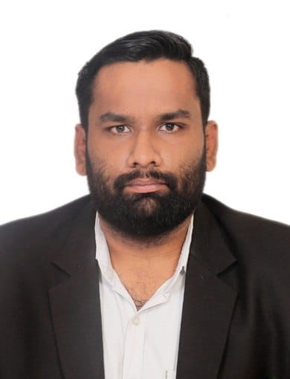

|  |
| --- |
| **Sushant** Gupta  # 730, Sector – 11, PANCHKULA, HARYANA  Phone- 9780543346, 7719799596  Email ID- [sushantgupta027@gmail.com](mailto:sushantgupta027@gmail.com)  LinkedIn Profile - https://www.linkedin.com/in/sushant-gupta-b94a64175 |
| I have good knowledge in criminal trials, civil suits, complaints filed under HRERA, Consumer Court, Drt. Pleadings and drafting skills are good. I have good knowledge of MS Office such as M.S Word, Excel and Power Point. |

# Experience

|  |
| --- |
| 2017– To 2021Done Internship under Sh. Anirudh kush advocate during college time At the time of college, I have started my internship under Sh. Anirudh Kush practicing in District Court Panchkula and I learnt many things such as how to draft a case and further how to plead the case. |
| 2021 – till datedoing independently After completing my Batchler’s in law in 2021. I started to work independently in District Court Panchkula and Punjab and Haryana High Court. |

# Education

|  |
| --- |
| Class X - 2014Satluj public school, sector – 4, Panchkula, Haryana I have cleared my class 10th from CBSE on 20-05-2014 with 8.2 CGPA. |
| Class Xii - 2016Satluj public school, sector – 4, Panchkula, Haryana I have cleared my class 12th from CBSE on 21-05-2016 with 58 %. B.a.ll.b (hons.) - 2016-2021Swami devi dyal college of law affiliated with Kurukshetra university I have cleared my B.A.LL.B (HONS.) from Swami Devi Dyal College of Law which is affiliated with Kurukshetra University on 06.09.2021 with First Division. |

# Skills

|  |  |
| --- | --- |
| * Good Pleading * Good Drafting Skill | * Good Knowledge of Law * Good knowledge of MS. Office |

# Enrollment

I HAVE CLEARED THE ALL INDIA BAR EXAMINATION AND OBTAINED CERTIFICATE OF PRACTICE ON 14TH OF SEPTEMBER, 2021.

I AM MEMBER IN PUNJAB AND HARYANA HIGH COURT AND DISTRICT COURT PANCHKULA.